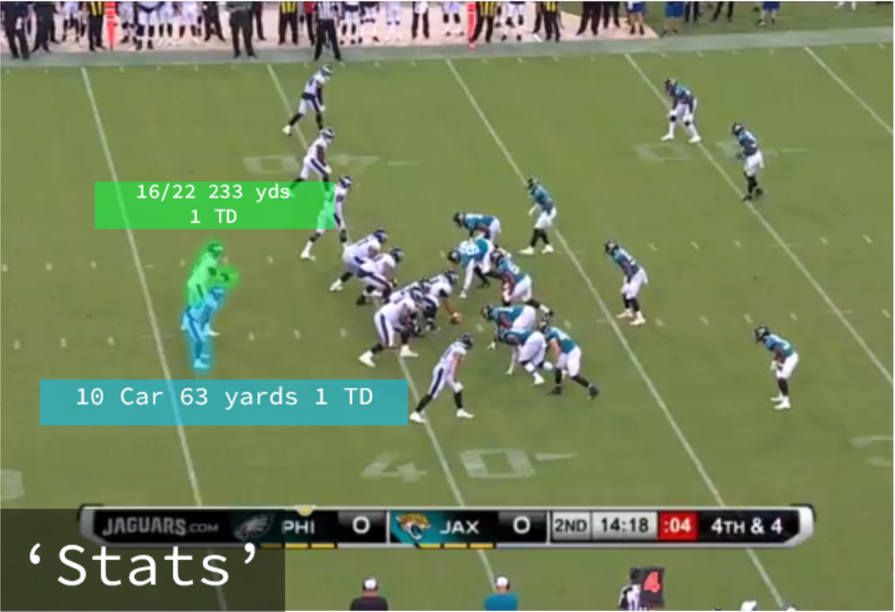

<https://saturdaytradition.com/wp-content/uploads/2019/08/Screenshot-601-718x490.png>



<https://cdn.apartmenttherapy.info/image/upload/v1561242428/stock/shutterstock_373602469.jpg>



<https://img.huffingtonpost.com/asset/5dfa86da2500004071d309fc.jpeg?cache=58kXzb9iCn&ops=scalefit_720_noupscale>



<https://live.staticflickr.com/2818/12507065445_5acf53e8f5_b.jpg>



[https://thumbor.thedailymeal.com/0rin8e8fI1YNc27rb6sRSBJw2HY=/870x565/filters:focal(498x331:499x332)/https://www.thedailymeal.com/sites/default/files/2019/04/05/0-main-mamouns.JPG](https://thumbor.thedailymeal.com/0rin8e8fI1YNc27rb6sRSBJw2HY=/870x565/filters:focal(498x331:499x332)/https:/www.thedailymeal.com/sites/default/files/2019/04/05/0-main-mamouns.JPG)